1:

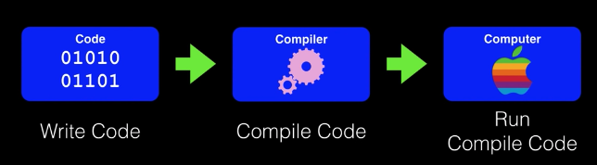

-When I run code complied for my computer, I am just running code complied for my computer’s architecture (Mac will only run on a Mac, Linux will run on a Linux)

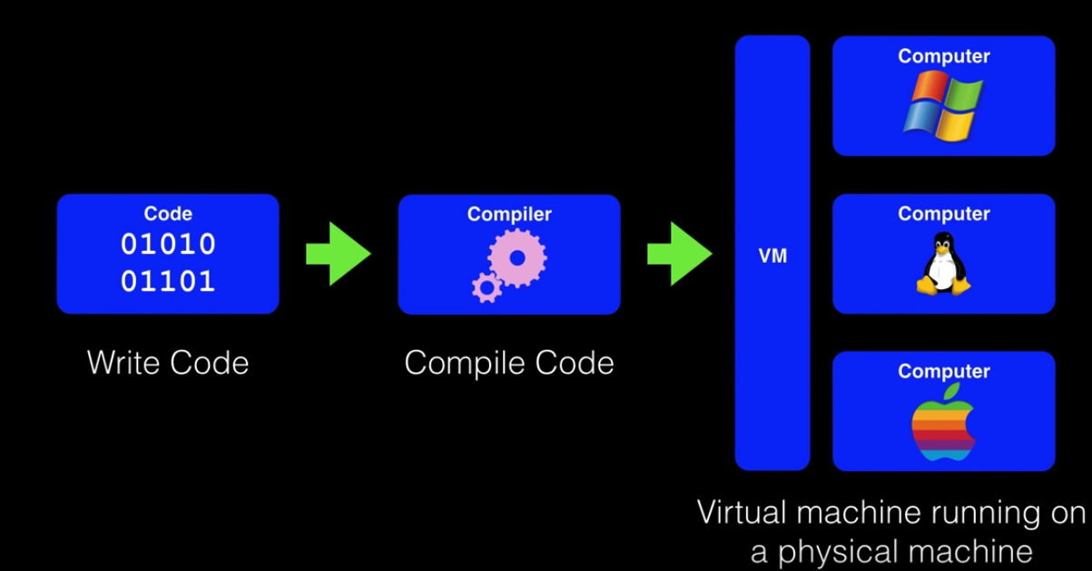

-One way to get around is to use a virtual machine. VM is a program that emulates the behavioral of a particular computer system. Advantages are you can compile once for a VM, and your program runs on any physical system that your machine can run on

-Taking code, compiling it on a VM, and any computer that can VM can run my complied code

-A VM reads instructions from your program and then translates it into instructions your computer can run

-When you write and compile a Java application, you are compiling it for a Java machine

-Now no one has a Java machine, we all run Macs, Linux or Windows

-JVM (Java Virtual Machine) when you install Java, you install this. Java applications you create are run on the JVM and this how Java achieves platform independence

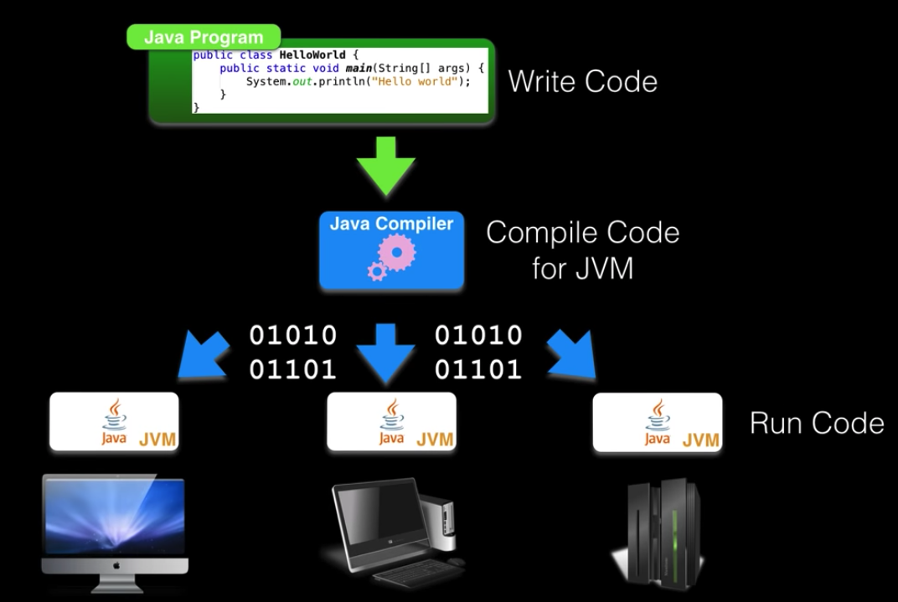

-The basic development flow for any Java program will be to write the Java code into a text file compile the Java code into class files which are then fed to JVM

-JVM interprets the class file into code your machine can understand

-When you download a VM, also downloading the JRE (Java Runtime Environment)

-JRE contains libraries and the JVM you need to run Java programs. The JRE however does not contain what you need to write and debug Java programs, need the JDK for that

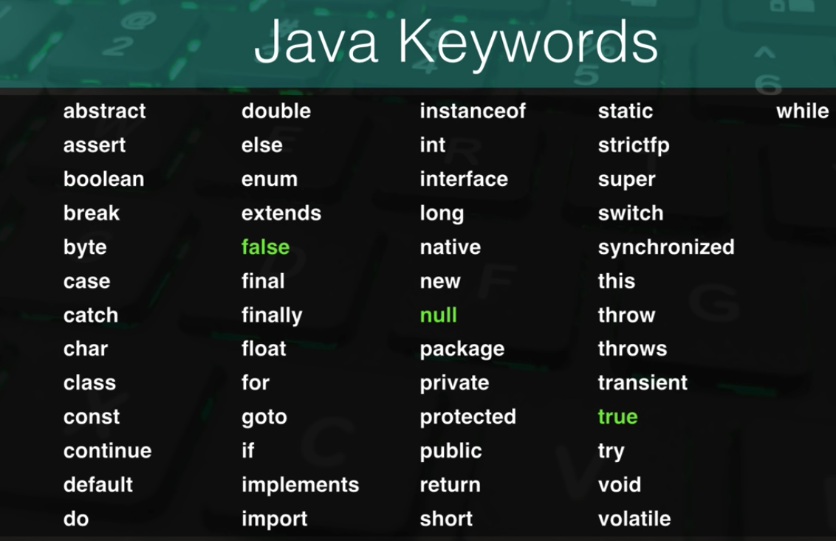

-false, null, true not keywords but literal values. “23” is a literal number, “true” is a literal Boolean value

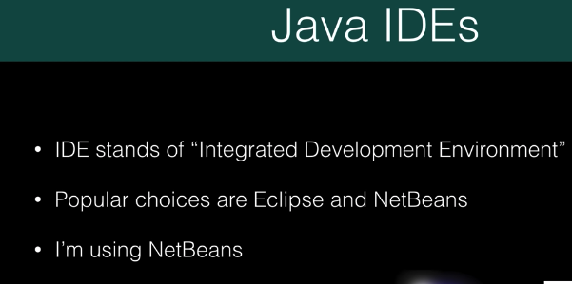

2:

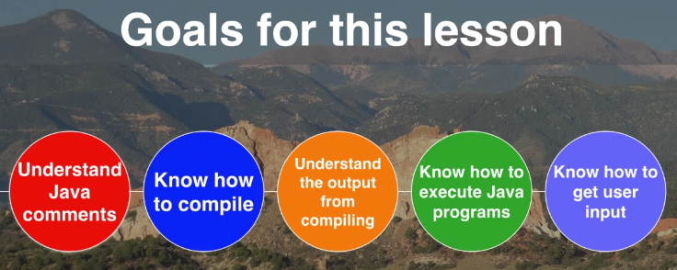

-javac HelloWorld.java

Makes the HelloWorld.class file which contains instructions for the JVM to run, it is the result of compiling the Java file

-java HelloWorld

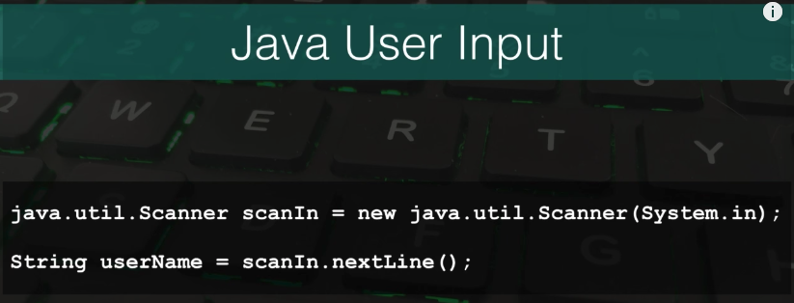

3:

Maven is a tool used to build larger projects.

4:

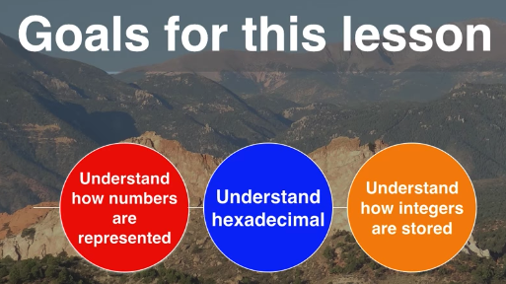

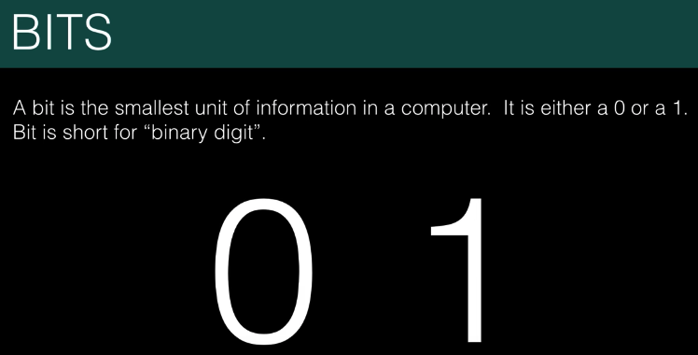

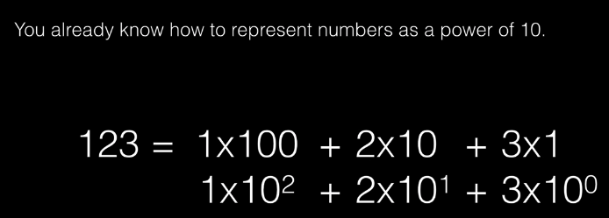

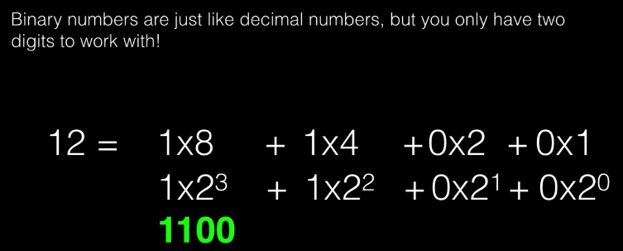

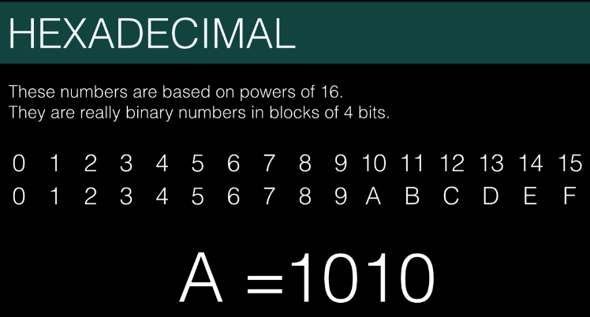

5:

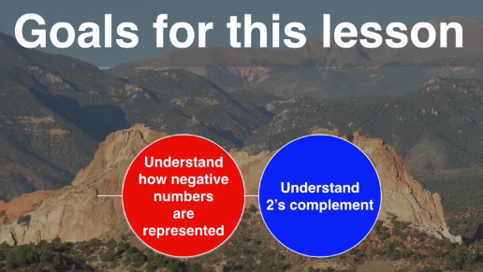

6:

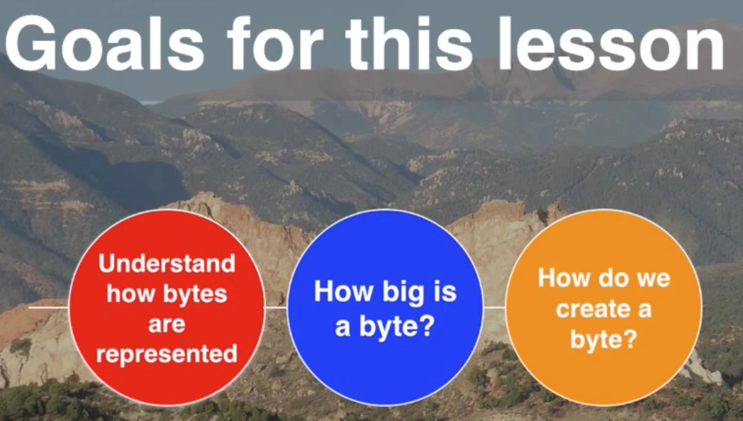

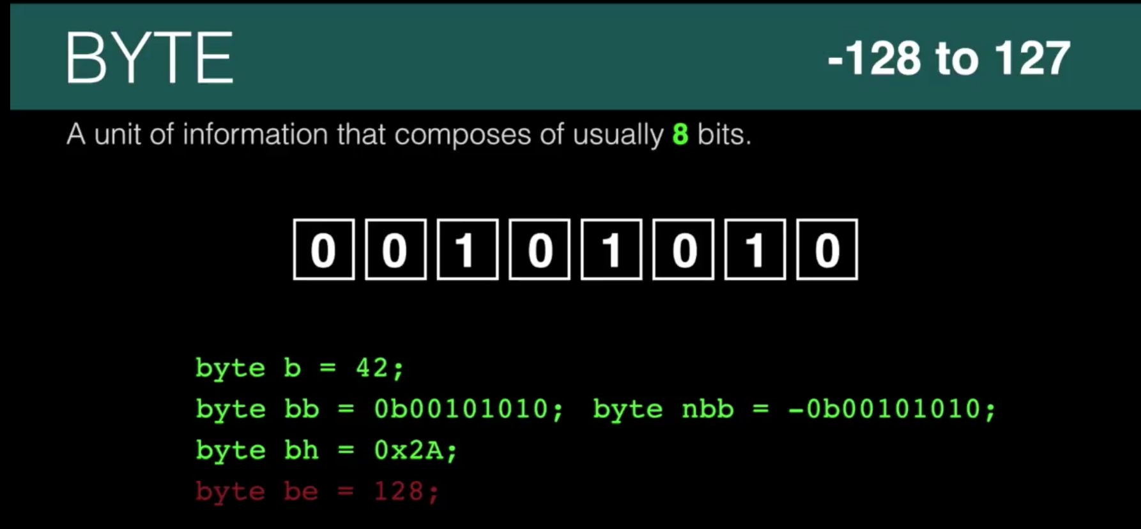

7:



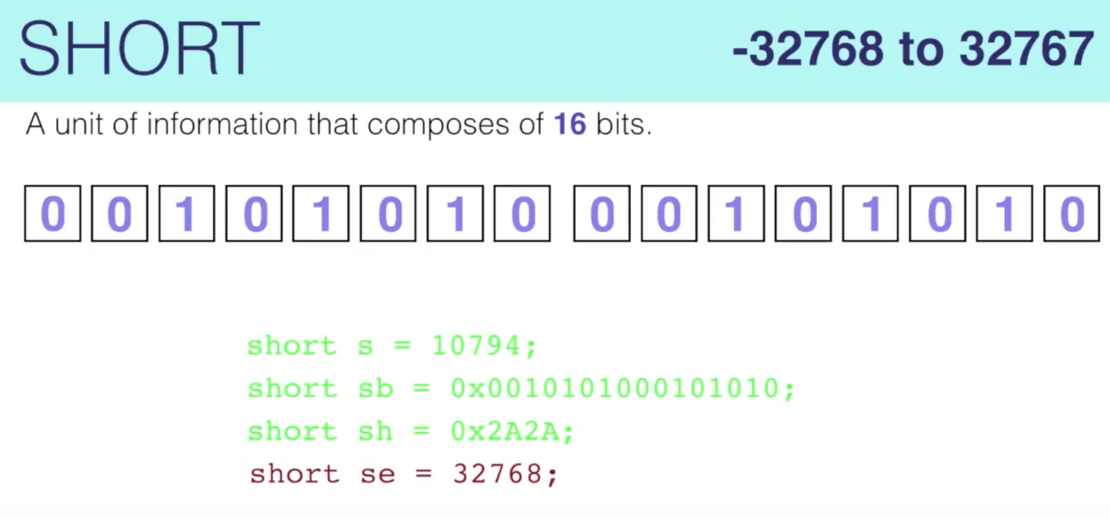

8:

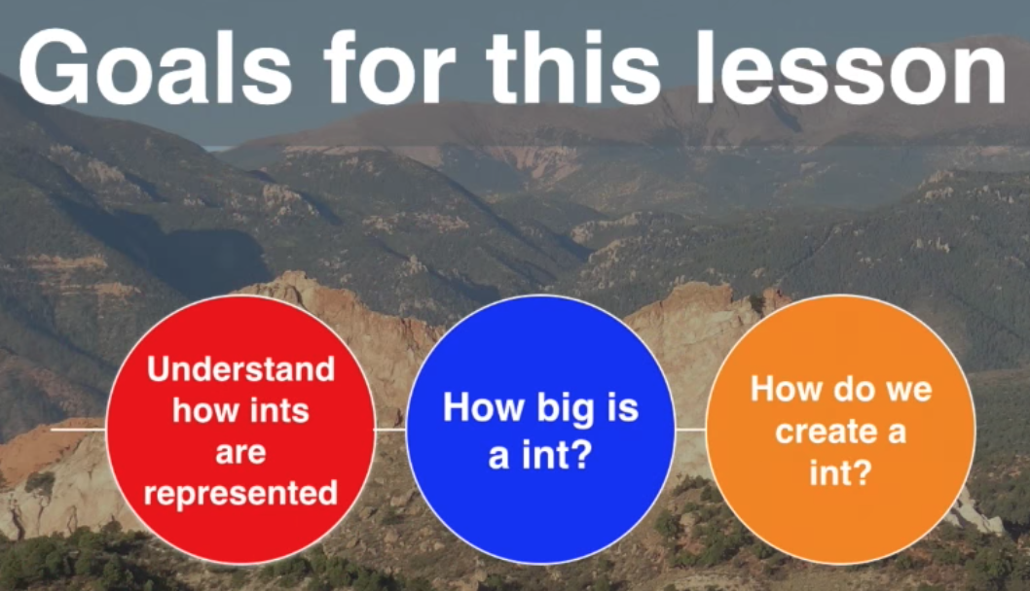

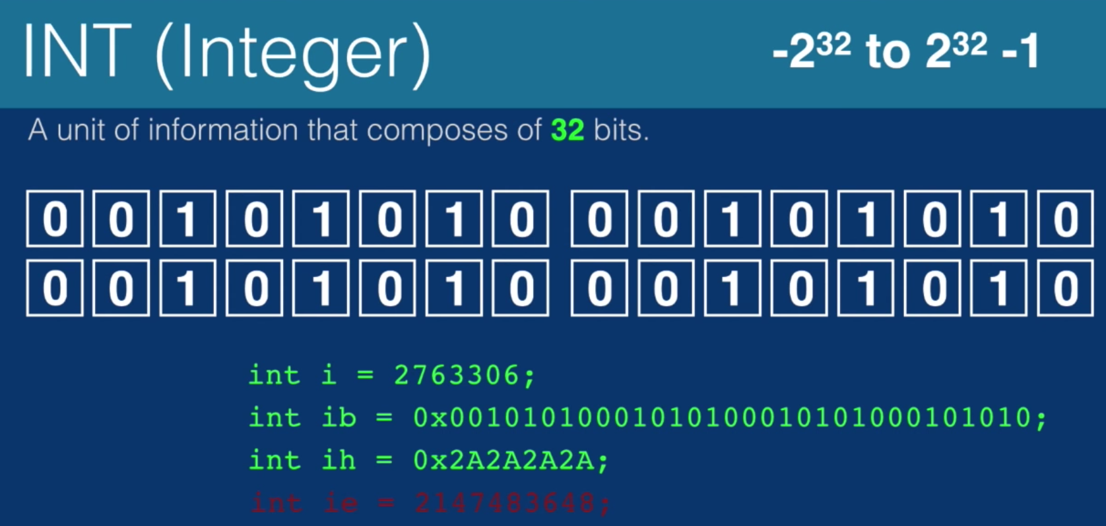

-This is a number from approximately negative 2 billion to positive two billion

-The actual number is 2^31 but large enough to call it two gigabytes

-More shit

9:

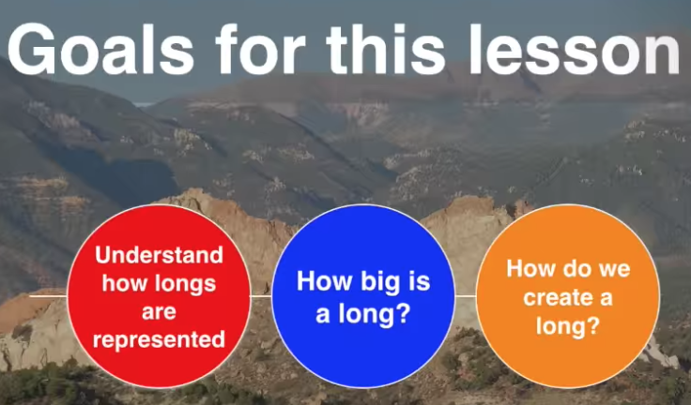

-Something you want to use if you need over two/four billion

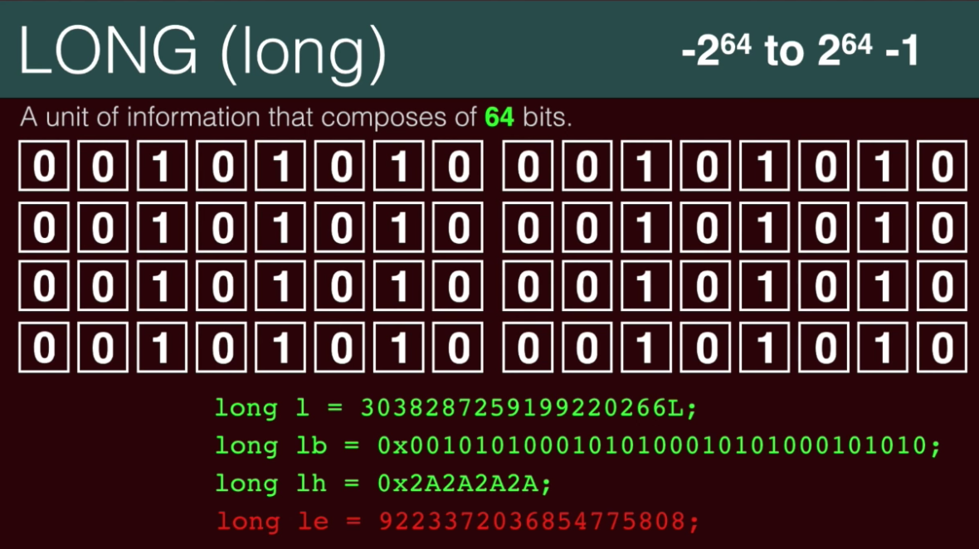

10:

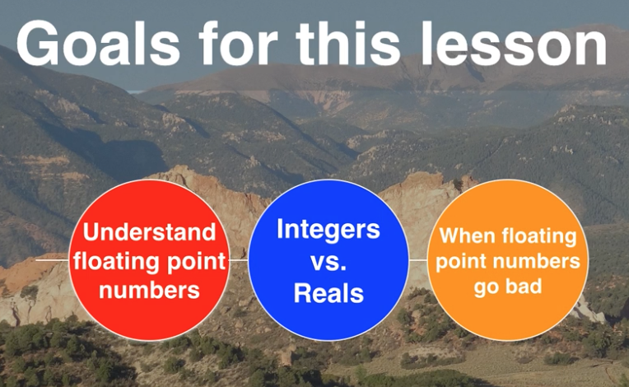

11:

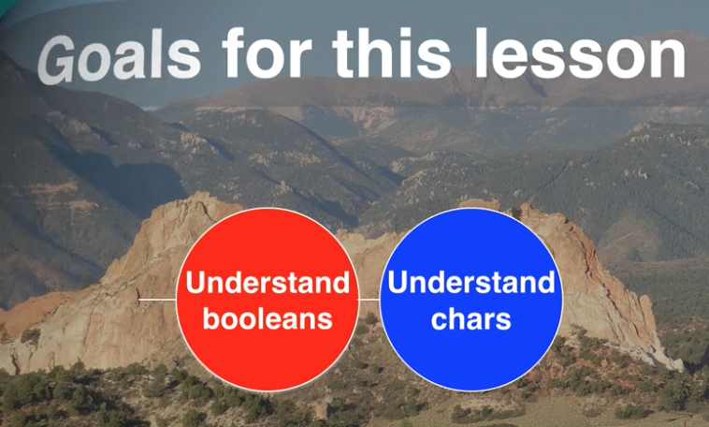

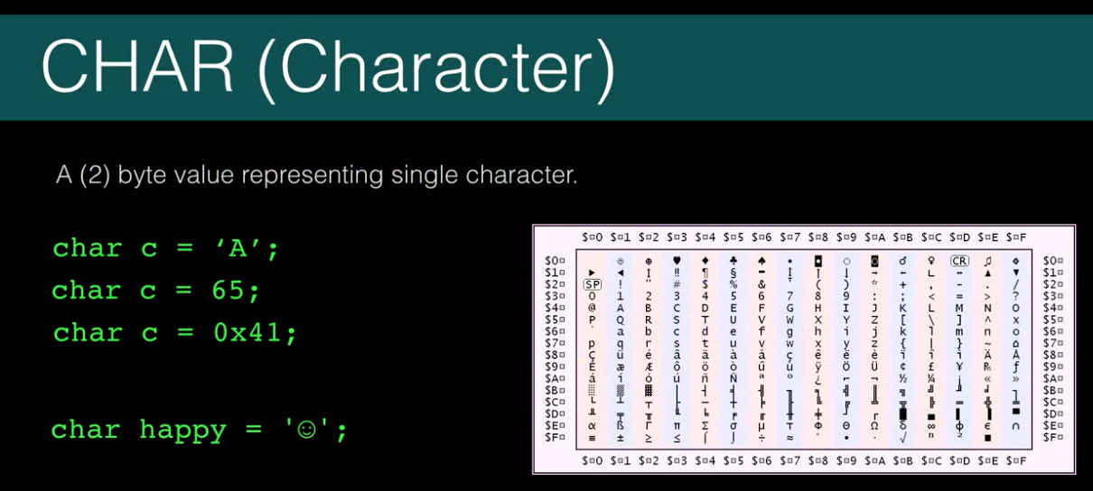

-Character is a 16 bit Unicode character

-Unicode is the standard for representing characters from any language

-char c = ‘A’; char c = 66; char c = 0x44;

12: Java Variables

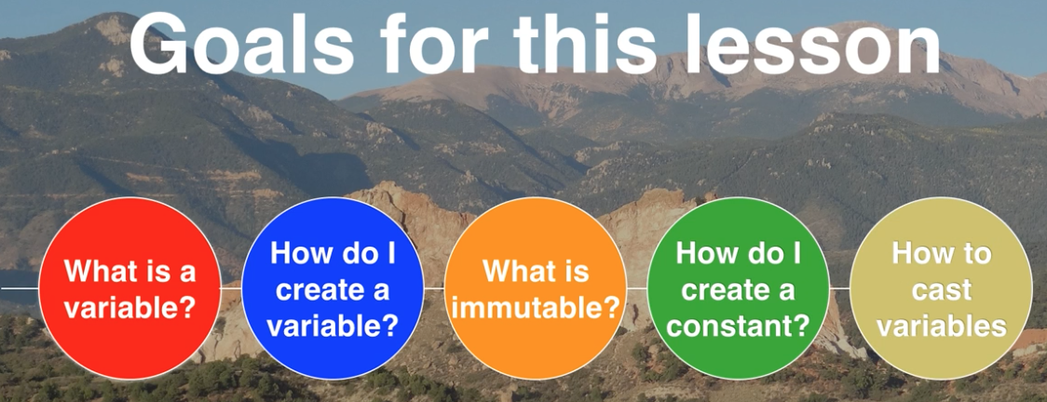

-Immutable means variable cannot change once it’s set

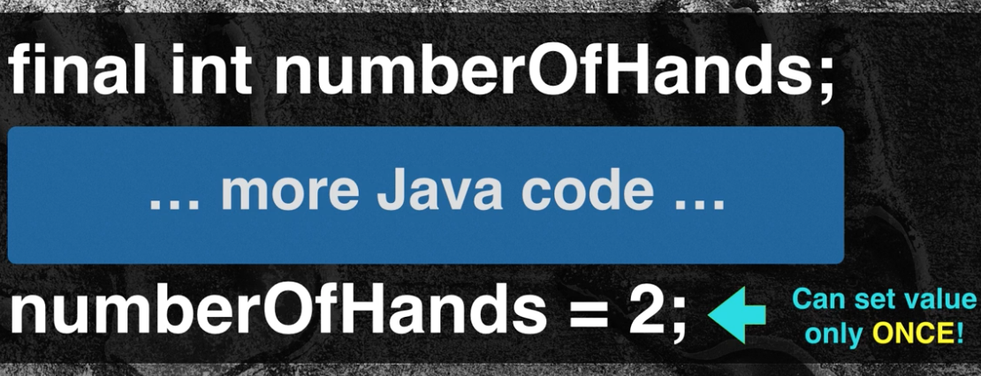

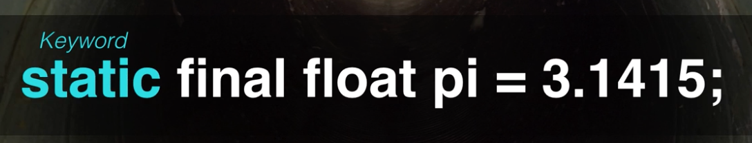

-static final means const

-static really means set at compile time

-static final constant must be created outside of a method

-Difference between constant and immutable, you know the value of the constant at compile-time. Immutable isn’t known until runtime

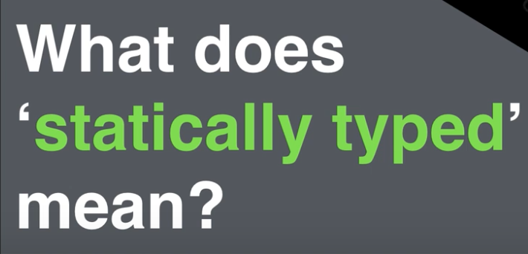

-Once you give a variable type, you can’t change it because Java is a statically typed language

-Means the value is typed at compile time

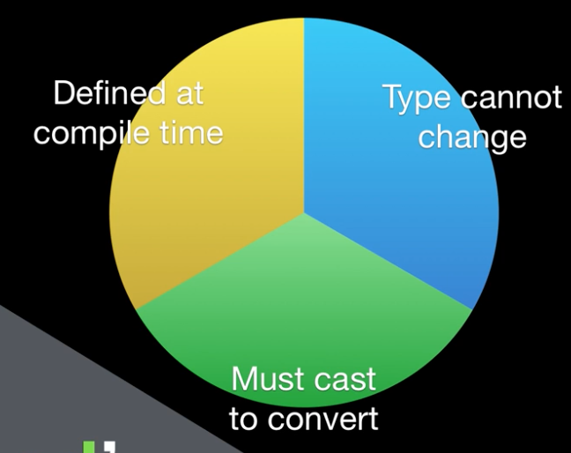

-Opposite of statically typed is dynamically typed which means variable can change type at runtime (Perl)

-One good reason is it catches stupid errors at compile time

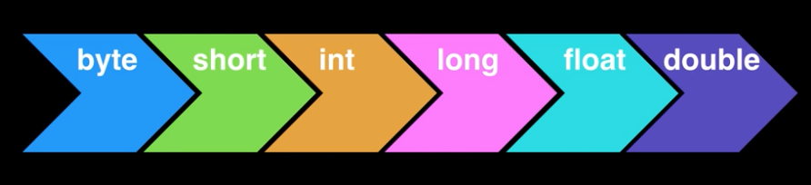

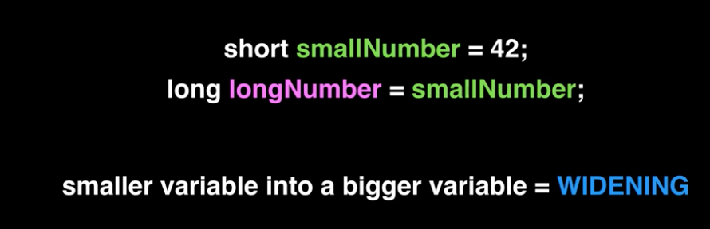



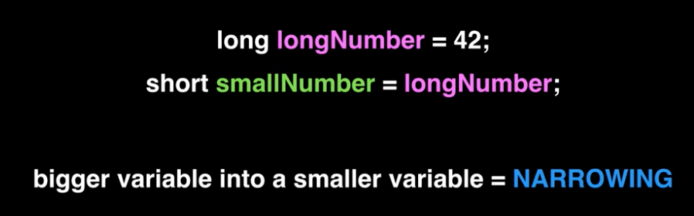

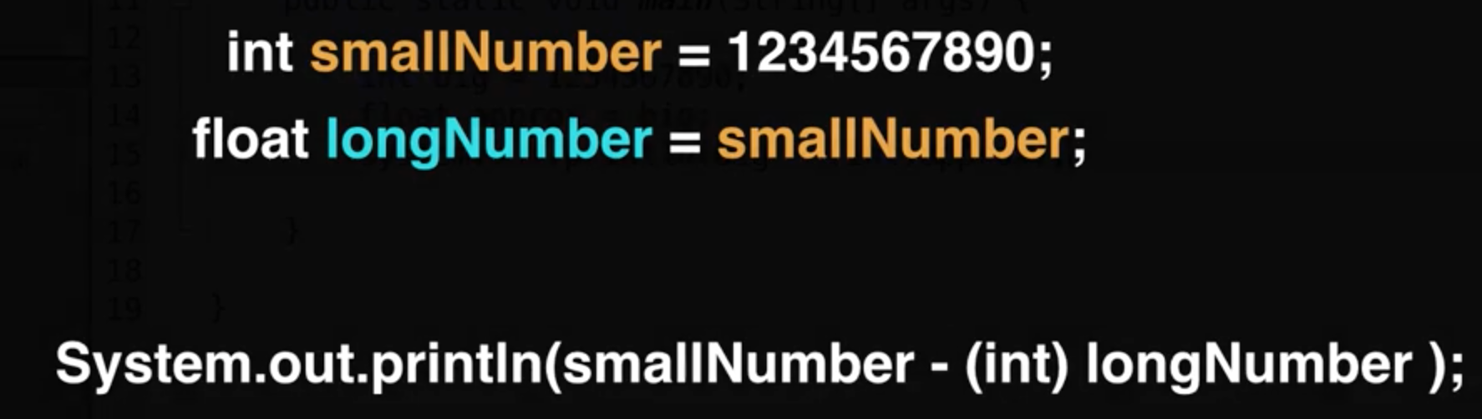

13: Java Array

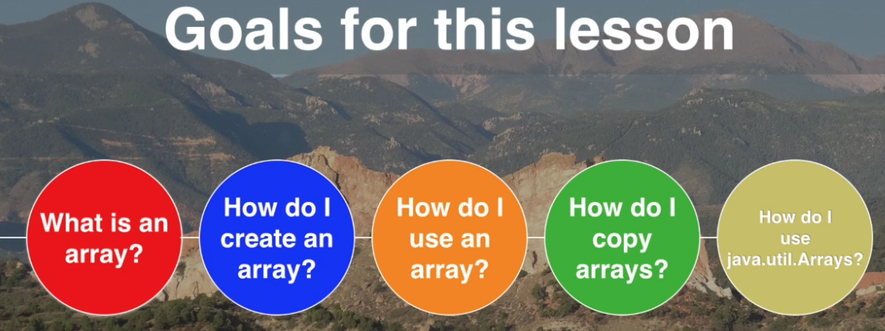

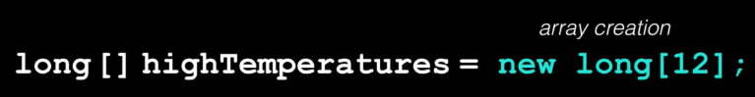

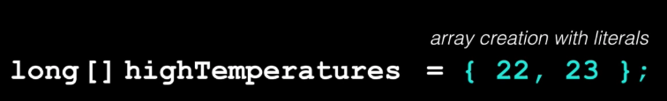

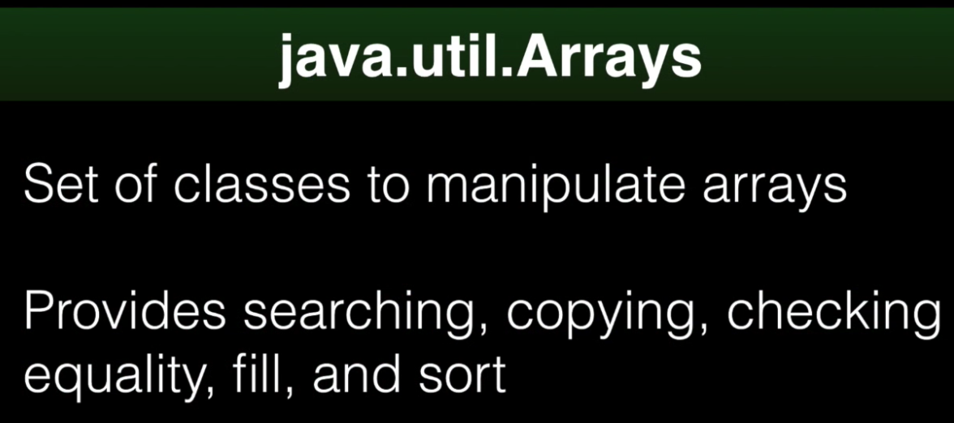

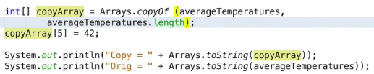

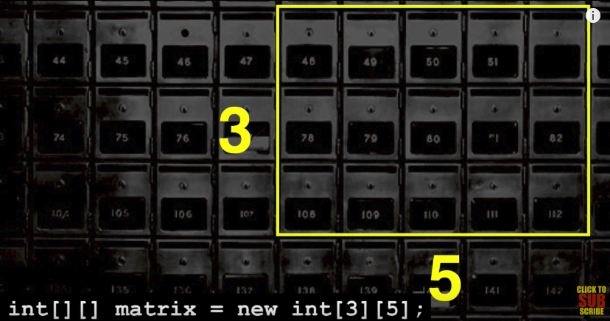

14: Java Operators

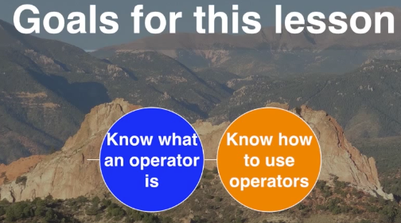

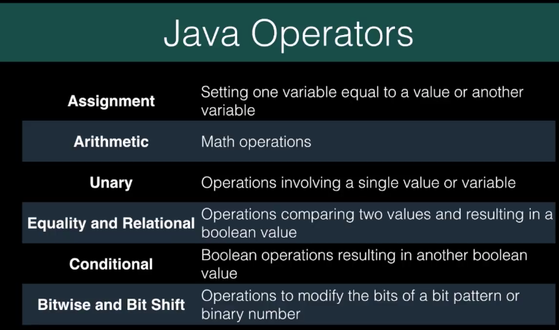

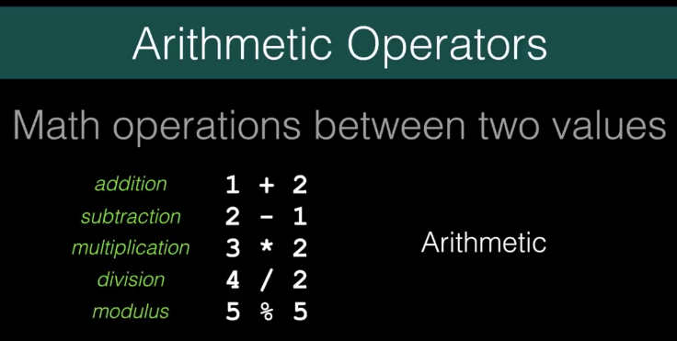

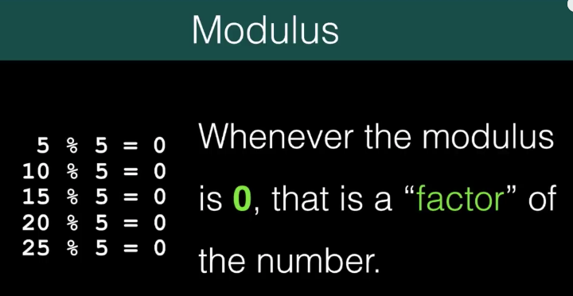

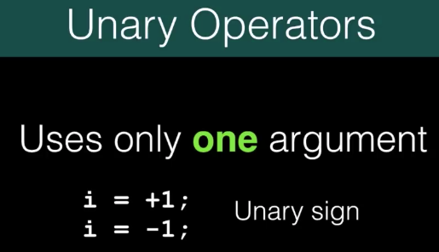



15:

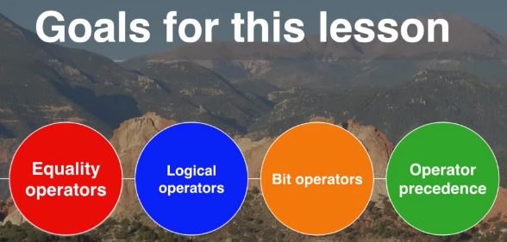

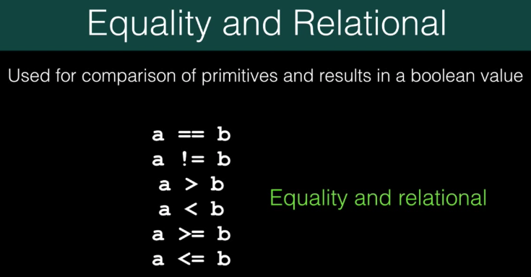



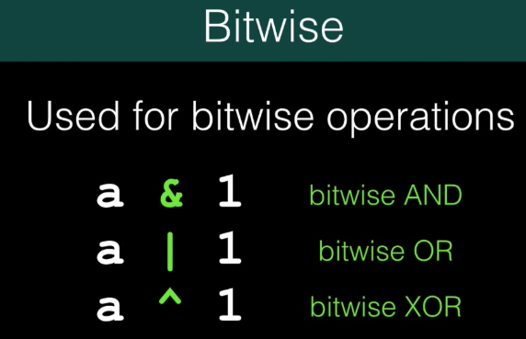

-These take two integer types and return an integer or a long. That’s important, if you use these operations on two bytes, or two shorts, the result will be an int. The result is always an int or a long unless you cast it back down

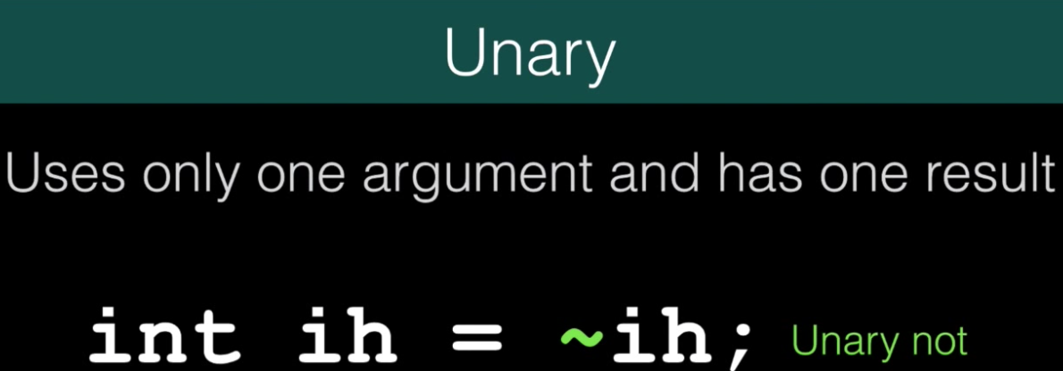

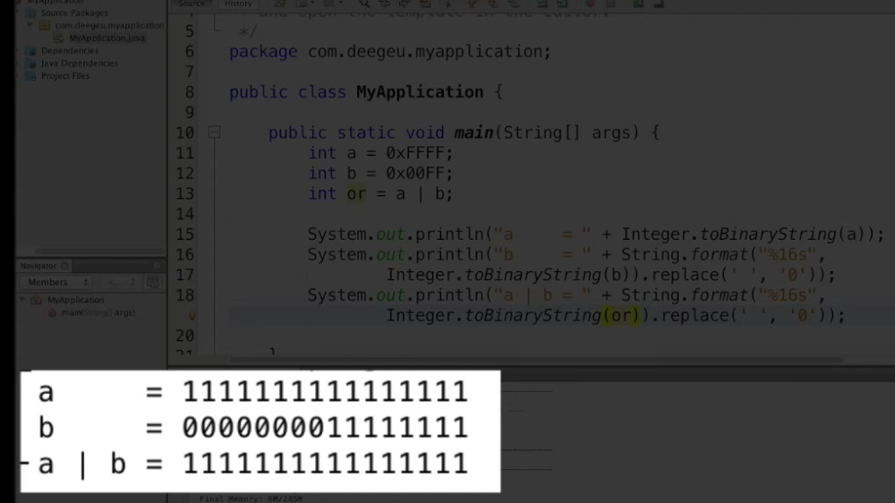

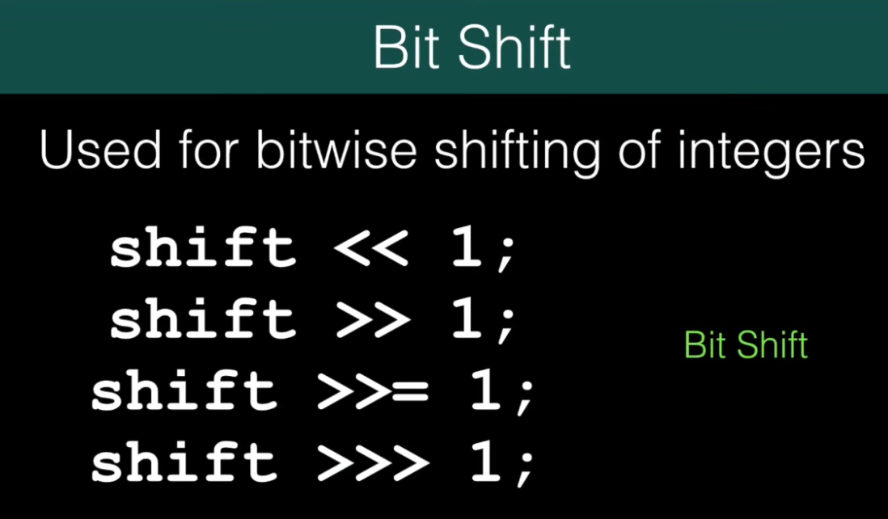

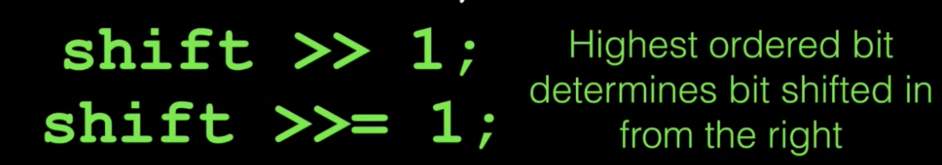



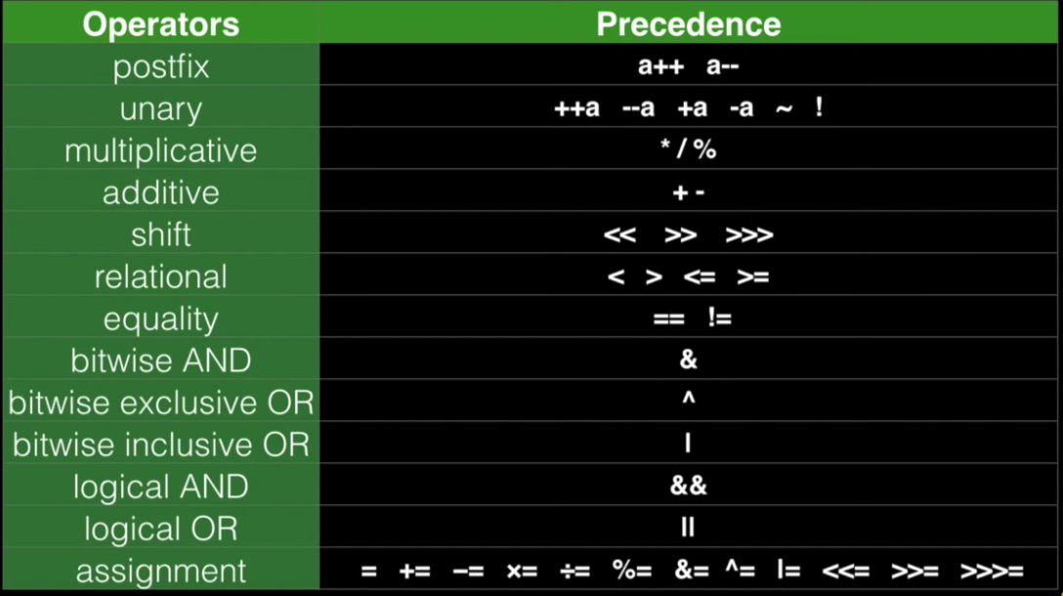

16 Java Blocks

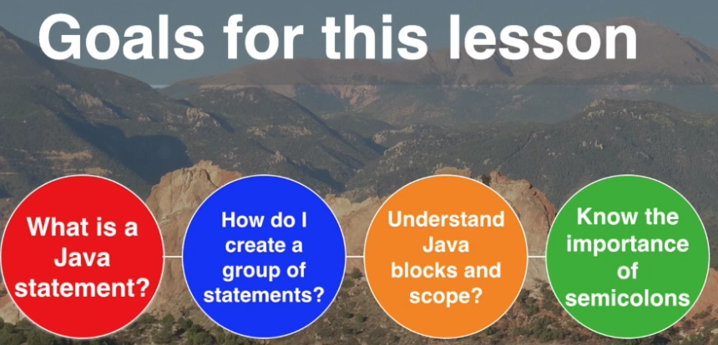

17: Switch

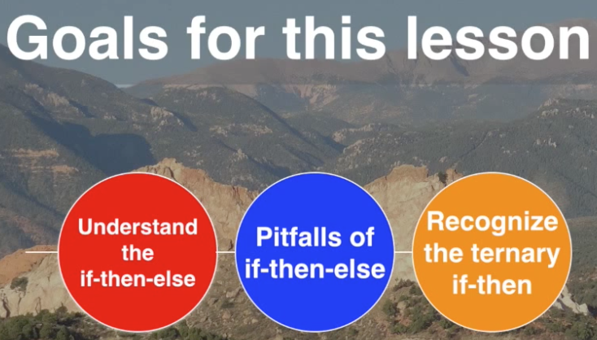

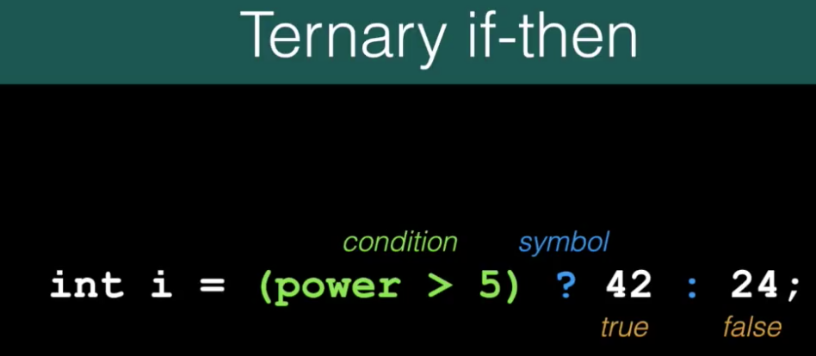

18 Switch